**Databases**

**SQL Assignment**

**You must submit a word document via Moodle. Your word document must contain snapshots of the console or MySQL workbench showing the SQL query and result set.**

**Note**:  You should use the doctor script to set up the tables

1. Write an SQL query to show how many days you have been alive (This query is not related to theDocs database and should be calculated  using datediff function)

**Ans.** SELECT DATEDIFF (curdate(), '19981107') as "Days_Alive" ;

**Output:**

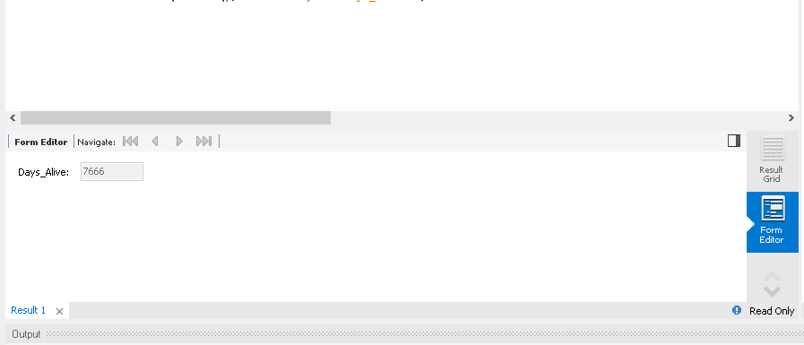

1. Update Doctor Lily Burke’s lastName to a lastName of  your choice

**Ans**. update doctors set lastName = "Anderson" where firstName = "Lily";

**Output:**

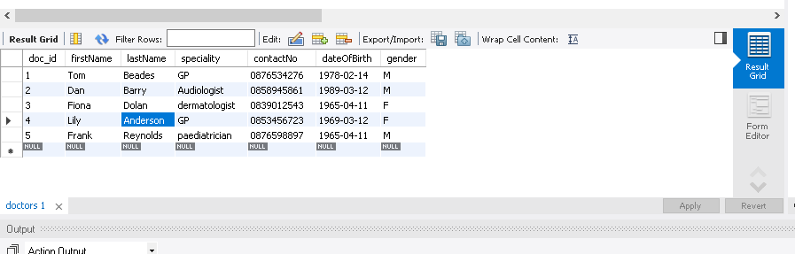

1. What is the name and price of the most expensive drug in the drugs table?

**Ans.** select drug_name,cost from drugs where cost = (select max(cost) from drugs);

**Output:**

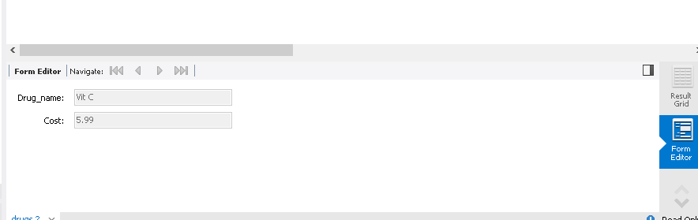

1. What is the name of the least expensive drug in the drugs table?

**Ans.** select drug_name,cost from drugs where cost = (select min(cost) from drugs);

**Output:**

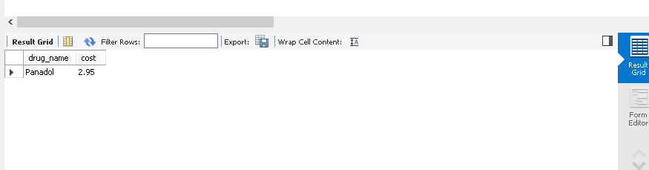

1. Select the patients who have no address2 details stored in thedoc patients table.

**Ans.** select * from patients where address2 is null;

**Output:**

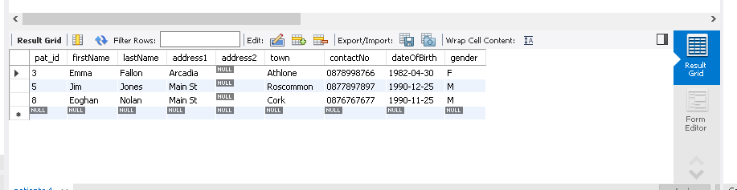

1. Choose 1 of these patients and update their details to store an address2 (Pick any town of your choice) in thedoc patients table. (You must show the command – i.e.  don’t edit the field directly in MySQL workbench)

**Ans.** update patients set address2 = "XYZ Monksland" where pat_id = 3;

**Output:**

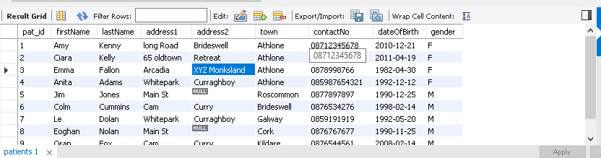

1. What is the average cost of a drug in the drugs table?

**Ans.** select avg(cost) as "Average Cost" from drugs;

**Output:**

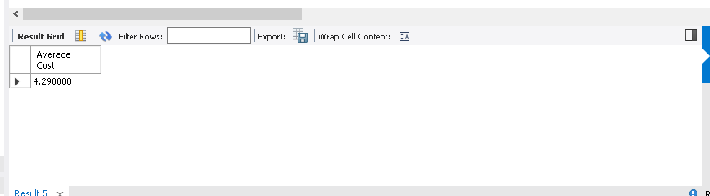

1. Count the different specialties of thedoc surgery

**Ans.** select count(distinct(speciality)) as "No_of_from_speciality" from doctors ;

**Output:**

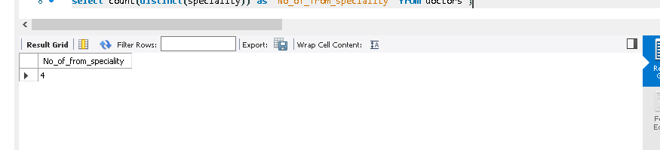

1. List the different specialities of thedoc surgery displaying the specialities in UPPERCASE letters.

**Ans.** select upper(speciality) as "Speciality" from doctors group by speciality ;

**Output:**

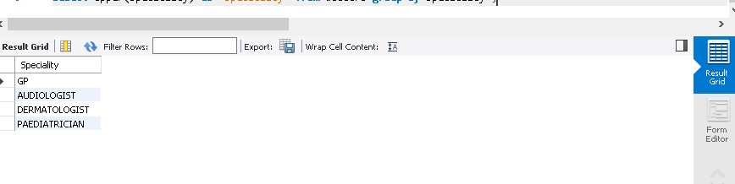

1. How many prescriptions did the paediatrician write?

**Ans.** select count(*) as "No. of prescriptions" from prescriptions;

**Output:**

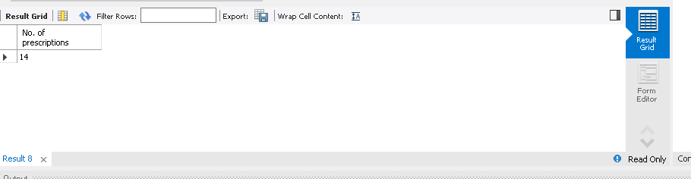

1. What are the names of the doctors who wrote the prescriptions for patient 6?

**Ans.**  select doctors.firstName,doctors.lastName from doctors INNER JOIN prescriptions ON doctors.doc_id = prescriptions.doc_id where prescriptions.pat_id = 6;

**Output:**

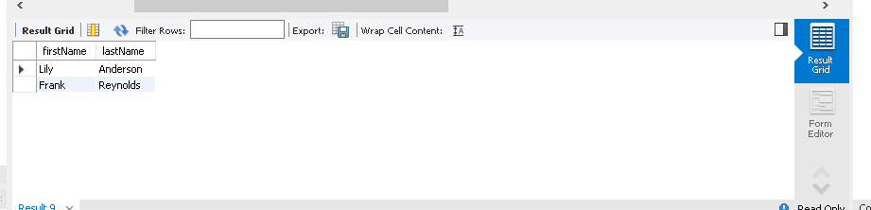

1. List the firstName, lastName of all the patients who had **no** prescription written for them.

**Ans.** select patients.firstName,patients.lastName from patients left JOIN prescriptions ON patients.pat_id = prescriptions.pat_id where prescriptions.pat_id is null;

**Output:**

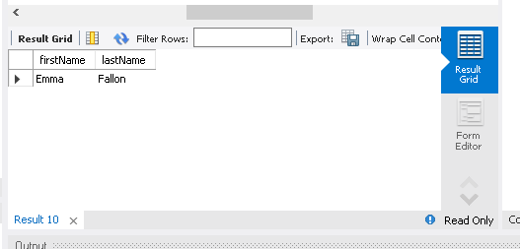

1. Insert any drug of your choice into the drugs table

List all the drugs in the drugs table – verifying your drug was added

**Ans.** INSERT INTO drugs VALUES ( null, 'Vit D', 6.9);

**Output:**

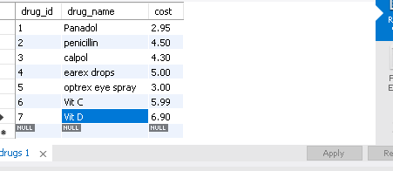

1. Now list all drugs that have been prescribed by the Doctors – your drug should not appear in the list

**Ans.** select distinct drug_name from drugs inner join prescriptions on drugs.drug_id = prescriptions.drug_id ;

**Output:**

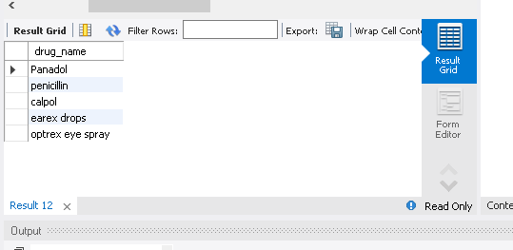

1. Add an attribute “Manufacturer” to the drugs tables.

**Ans.** alter table drugs add Manufacturer varchar(100);

**Output:**

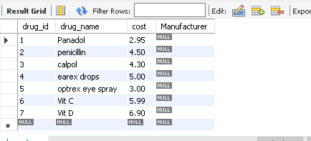

1. Update the drugs tables to record the manufacturer of Panadol and Calpol as GlaxoSmithKline.

**Ans.** Update drugs set Manufacturer = "GlaxoSmithKline" where drug_name = "Panadol" or  drug_name = "Calpol";

**Output:**

